Care Home

Infection Prevention and Control
Self Audit and Toolkit

Name of Care Home | Manager | Date of Audit
Provider/Proprietor | Name of Auditor/Position | Review Date of Audit

Contents |  | Page Number
1 | Introduction | 3- 4
2 | Standard 1 – Environment | 5-13
3 | Standard 2 – Hand Hygiene | 14-16
4 | Standard 3 – Personal Protective Equipment (PPE) | 17-18
5 | Standard 4 – Sharps and Blood and Body Fluid (BBF) Exposure | 19-20
6 | Standard 5 – Waste | 21
7 | Standard 6 – Decontamination and Disinfection | 22-24
8 | Standard 7 – Clinical Practice | 25-27
9 | Standard 8 – Organisational Controls | 28-29
10 | Results / compliance rating | 30
11 | IPC Action Plan | 31- 38
12 | Appendix1:Resources/Posters | 39- 50

Introduction

Welcome to the updated Infection Prevention and Control (IPC) Self Audit Tool for Care Homes. Audit is a requirement of the Health and Social Care Act 2008,Code of practice for registered providers on the prevention and control of healthcare associated infections and related guidance which states that registered providers must audit compliant against key infection prevention and control policies and procedures. Ideally, for quality and assurance purposes registered Care Home providers should complete an IPC audit annually.

For Care Homes with NHS Leeds Commissioned beds a face-to-face IPC audit will be undertaken and completed by the Leeds Community Healthcare IPC Team on a three yearly basis.

This comprehensive audit is based on the Department of Health (2006) IPC audit tool, in order to gain an overall perspective and insight of the Care Home the IPC audit must include the following areas:

• Reception
• Day room / lounge(s) / dining room
• Communal bathrooms/ communal toilets / and staff toilets
• Minimum of 4 residential rooms (including en-suite)
• Sluice
• Laundry
• Domestic (housekeeping room)
• Treatment Clinical room

Self assess against each of the audit standards entering Yes, No or N/A in the appropriate box for the whole audit. You can in the end column add any notes you may have.

Please be as honest in this assessment as possible so that problems and issues may be resolved in advance of any review from official bodies, e.g. Leeds Community Healthcare Infection Prevention and Control; Care Quality Commission (CQC) and Local Authority.

An easy to use scoring system enables Care Homes to highlight the percentage risk for each standard.

How to work out the percentage score for each standard:
Add the total number of “Yes” answers and divide by the total number of questions answered (including all “Yes” and “No” answers)
excluding the “n/a” answers: multiply by 100 to get the percentage

Formula: Total number of “yes” answers x100= % Total number of “yes” and “no” responses

85%or above | Compliant | Low risk
76 – 84% | Partial Compliance | Medium risk
75%or below | Minimal Compliance | High risk

Once completed an action plan can then be formed, where progress can be monitored.

Please note, audit activity is based on best practice. The completed audit does not have to be returned to the infection prevention and control team.

However, for quality and assurance purposes please retain for your records.

Standard 1:

The environment must be maintained appropriately to reduce and minimise the risk of cross infection.
General Environment  (Reception; Lounge and Dining areas; Communal bathrooms; Toilets; Residents rooms & en-suites; Sluice; Domestic house keeping; Laundry; and Pets) |  | YES | NO | N/A | Notes
Ref  1.1 | Communal and residents rooms are free from unpleasant smells /mal-odours
1.2 | The general environment is clean and free from dust
1.3 | Curtains  Curtains and blinds are free from stains, dust and cobwebs
1.4 | There is a cleaning programme in place for regular decontamination for all curtains and blinds (evidence of signing sheet)
1.5 | Carpets:  Carpeted areas are clean and in a good state of repair
1.6 | There is a robust cleaning programme in place for the steam cleaning of carpets in both communal and residents rooms (evidence of frequency documented)
1.7 | Furniture:  The furniture is in a good state of repair and is free from rips and tears

1.8 | Furniture in residents areas, e.g. chairs and settees, are made of impermeable and washable materials
1.9 | There is a cleaning programme in place for regular decontamination of furniture  (evidence of frequency documented)

Clinical Room /Treatment Room |  | YES | NO | N/A | Notes
Ref  1.10 | There is an identified area for the storage of clean and sterile equipment
1.11 | All items of sterile equipment are in date and intact (randomly check 2 items)
1.12 | Dressing trolleys are clean and in a good state of repair
1.13 | Suction unit is clean and dry
1.14 | Staff are able to recognise the single-use symbol
1.15 | Single-use items are not re-used or re-processed
1.16 | The ventilation is suitable and appropriate for the room

1.17 | Hand hygiene facilities are available in the clinical room
1.18 | Impervious flooring including edges and corners are free of dust and grit
1.19 | All high and low surfaces are free from dust and cobwebs
1.20 | Shelves, bench tops and cupboards are free from clutter and clean inside and out, and are free from dust and spillage
1.21 | All products items are stored above floor level

Bathrooms |  | YES | NO | N/A | Notes
Ref  1.22 | Bathrooms/washrooms are clean
1.23 | There is no evidence of inappropriate storage of communal items e.g. single-use creams, talcum powder, flannels
1.24 | Anti-slip bath/shower mats are clean and hung over the bath/rail to dry between use
1.25 | Lifting aids are waterproof, easy to clean and appropriately maintained e.g. check underneath bath seats/slings
1.26 | Slings are single resident use or cleaned between each resident
1.27 | Slings contaminated with bodily fluids should be laundered immediately
1.28 | The mechanical hoist is clean and in a good state of repair
1.29 | Bathrooms are not used for equipment storage
1.30 | Baths, sinks and accessories are clean
1.31 | Appropriate cleaning materials are available to clean the bath after use
1.32 | Wall tiles and wall fixtures (including soap dispensers and towel holders) are clean, free from mould and intact
1.33 | Shower curtains are subject to a cleaning programme and are clean and free from mould
1.34 | To reduce the risk of Legionella grow there is documented evidence that baths, showers and sinks that are taken out of use have planned provision for weekly running of the water

1.35 | Floors including edges and corners are free of dust and grit

Toilets |  | YES | NO | N/A | Notes
Ref  1.36 | Hand washing facilities in communal toilets have only wall mounted liquid soap and paper towels dispensers (no bars of soap or fabric towels or nail brushes)
1.37 | A poster demonstrating the correct hand washing technique is above all communal hand wash facilities
1.38 | There is sufficient odour control
1.39 | Flooring is impervious and sealed including edges and corners and are free of dust and grit
1.40 | Toilet tissue is dispensed from a sealed tissue dispenser
1.41 | Hand washing facilities in residents own toilets (en-suite) have wall mounted liquid soap and paper towels dispensers for care workers to decontaminate hands at the point of care
1.42 | In each toilet area the bin must be foot operated pedal bin for disposal of paper towels lined with a domestic waste bag
1.43 | In communal toilets there is a facility for sanitary waste disposal with an appropriately coloured bag(offensive waste/clinical waste) and must be foot operated pedal bin
1.44 | All toilets are visibly clean with no body fluid contamination, lime scale stains etc

Sluice |  | YES | NO | N/A | Notes
Ref  1.45 | A dirty utility area is available
1.46 | A separate sink is available for decontamination of patient equipment
1.47 | A sluice hopper is available for the disposal of body fluids
1.48 | The integrity of fixtures and fittings are intact
1.49 | Separate hand washing facilities are available including liquid soap and paper towels
1.50 | The room is clean and free from inappropriate items
1.51 | The floor is clean and free from spillages
1.52 | Floors including edges and corners are free of dust and grit
1.53 | Cleaning equipment is colour coded
1.54 | Wash bowls are stored clean and dry and inverted on a rack, or are stored clean and dry in the resident’s room (for their use only)
1.55 | Bed pans, commode buckets, urinals and jugs are stored on inverted racks
1.56 | Commodes are visibly clean and cleaned after each use

1.57 | Commodes and commode frames are in a good state of repair and are subject to a weekly cleaning programme
1.58 | Appropriate facilities are available and are clean and in working order to ensure correct disposal or disinfection of bed pans and urinals (macerator and/or washer  disinfector)
1.59 | Shelves and cupboards are clean inside and out and free of dust, litter or stains

Domestic (House-keeping) Room |  | YES | NO | N/A | Notes
Ref  1.60 | There is a robust cleaning programme schedule in place for the regular decontamination throughout the establishment (documented evidence)
1.61 | Equipment used by the domestic is clean, well maintained and stored in a locked area in accordance with COSHH regulations
1.62 | Information on the colour coding system in use is available in the domestics’ room
1.63 | Personal protective equipment is available and appropriately used by housekeeping staff (gloves and aprons)
1.64 | Products used for cleaning and disinfection comply with policy and are used at the correct dilution
1.65 | Cleaning agents are stored in clearly marked containers
1.66 | Disposable cloths are colour coded
1.67 | Machines used for floor cleaning are clean and dry

1.68 | Colour coded buckets and mops are stored dry and inverted
1.69 | The room has no inappropriate materials or equipment stored

Laundry |  | YES | NO | N/A | Notes
Ref  1.70 | Laundry facilities are sited so that soiled articles, clothing and infected linen are not  carried through areas where food is stored, prepared, cooked or eaten and do not intrude on other service users
1.71 | The laundry floor finishes are impermeable and the wall finishes are readily cleanable
1.72 | Linen is segregated in appropriate categories
1.73 | Bags are less than 2/3 full and capable of being secured
1.74 | Water soluble or alginate bags are available for soiled/infected linen
1.75 | In the event of an outbreak of infection (e.g. diarrhea and vomiting) linen is laundered immediately
1.76 | Staff know how to handle soiled/infected laundry (randomly ask member of staff)
1.77 | Single-use gloves and aprons are available for use by laundry staff
1.78 | Staff are aware that manual sluicing is not good practice (randomly ask member of staff)

1.79 | Washing machines/tumble dryers are serviced regularly
1.80 | Clean linen is stored in a clean, dry area(not in the sluice/bathroom)
1.81 | Hand washing facilities are available in the laundry room with wall mounted liquid soap and paper towel dispenser
1.82 | Hand washing facilities are free of clutter and accessible
1.83 | Waste  A foot operated pedal bin is available for disposal of paper towels

Pets |  | YES | NO | N/A | Notes
Ref  1.84 | Animals used for pet therapy are appropriately wormed and vaccinated and have a flea management programme
1.85 | Evidence that pets feeding areas, cages, and bedding is changed and cleaned regularly
1.86 | Posters encouraging hand hygiene after handling animals are visible in healthcare environments - must apply to staff and visitors
 | Total number of “yes” answers x 100 = % Total number of “yes” and “no” responses
Standard 1
Total Percentage Score%

Standard 2:
Hands will be decontaminated correctly and in a timely manner, to reduce the risk of cross infection.
As a minimum a hand wash basin, wall mounted liquid soap dispenser and wall mounted disposable paper towels dispensers must be provided in each resident’s room for use by health and social professionals, carers and relatives.
This provision must also extend to toilets, sluices, treatment rooms, laundry and kitchen areas. Alcohol rub must also be available to care staff and positioned in appropriate areas.
Ref | Standard2 | YES | NO | N/A | Notes
2.1 | Wall mounted liquid soap (sealed single-use cartridge) is available at all hand wash sinks  (liquid soap must not be topped up)
2.2 | Soap dispensers including nozzles are visibly clean and not leaking
2.3 | Wall mounted paper towels available at all hand wash sinks (including in residents rooms for care staff to dry their hands on)
2.4 | Wall mounted or pump dispenser hand cream is available for use (do not re-filled)
2.5 | There are no nail brushes on sinks in communal areas
2.6 | The hand wash sinks are free from used equipment and inappropriate items
2.7 | Hand hygiene posters promoting hand decontamination are displayed above every communal hand basin sink
2.8 | Hand washing facilities are clean and intact (check sinks, taps, splash backs)

2.9 | Elbow operated or automated taps are available in hand wash sinks in clinical / treatment rooms
2.10 | Taps in clinical areas are thermostatically controlled leaver or mixer taps
2.11 | All care staff are 'Bare Below the Elbows';  (No wrist watches/stoned rings or other wrist jewellery are worn by staff carrying out care)
2.12 | The nails of care workers carrying out care are short, clean and free from false nails and free from nail varnish
2.13 | Staff have received training in infection prevention and control that includes specific hand hygiene training
2.14 | Infection prevention and control and specifically hand hygiene is an integral part of induction for all staff
2.15 | All residents are actively encouraged to use hand hygiene facilities after using the toilet/commode/bedpan
2.16 | Alcohol hand rub is available for use at point of care.
2.17 | All residents are offered hand hygiene facilities prior to meals
2.18 | Visitors /guests are actively informed to decontaminate their hands before and after leaving the establishment (clear notice on all entrances / exits)
2.19 | Hand hygiene facilities are available for visitors / guests to use

Observational hand hygiene assessments:  For purposes of quality assurances staff / carers must undertake observational hand hygiene assessments Essential Steps to Safe Clean Care tool bundle or equivalent |  | YES | NO | N/A | Notes
2.20 | Care and ancillary staff use the correct procedure for decontaminating hands (observe practice)  • Before and after each care activity  • After removal of gloves &aprons  • Prior to clinical procedures  • After a clinical procedure  • After handling contaminated items  • After leaving an isolation area  • Prior to handling food
2.21 | Care/nursing/ancillary staff can indicate when it is appropriate to use alcohol rub and when it is appropriate to use soap and water (question staff)
2.22 | Care/nursing/ancillary staff can indicate when it is more appropriate to use liquid soap and water rather than alcohol gel (for example, when providing care for residents with suspected Norovirus diarrhoea and vomiting and or residents with Clostrium (difficile)
 | Total number of “yes” answers x 100 = % Total number of “yes” and “no” responses
Standard 2
Total Percentage Score%

Standard 3:
Personal Protective Equipment (PPE) is readily available for staff to use throughout the home. All care staff and healthcare workers don PPE appropriately when undertaking care
Ref | Standard 3 | YES | NO | N/A | Notes
3.1 | Sterile non-powdered gloves are available for aseptic procedures  (x10 as a minimum at all times)
3.2 | Where staff or residents are latex-sensitive latex free gloves must be available for use
3.3 | CE non-powdered, non-sterile gloves are available for all staff
3.4 | Gloves and aprons must be worn as single-use items for each care intervention/task
3.5 | Gloves and aprons are stored appropriately to prevent cross contamination  (for example, do NOT store directly above toilets)
3.6 | Staff and carers, when handling body fluids ensure both disposable plastic aprons and gloves are readily available and worn
3.7 | Staff are aware of how to appropriately deal with spillages of blood or bodily fluids  (spillage kits available – held at a central point for staff to access)
3.8 | Appropriate gloves and aprons are available for domestic housekeeping duties
3.9 | Colour coded disposable aprons are available for staff use and used appropriately
3.10 | Masks, visors and eye protection are available for use.

Total number of “yes” answers x 100 = % Total number of “yes” and “no” responses

Standard 3
Total Percentage Score%

Standard 4: The safe management and disposal of sharps
All staff must be aware of what to do in the event of a sharps and needle stick injury (inoculation)
Ref | Standard 4 | YES | NO | N/A | Notes
4.1 | Robust inoculation injury policy is available for all staff to access
4.2 | All staff know the procedure to be followed should a sharps injury occur (ask one member of staff at random)
4.3 | Posters are visible regarding information of ‘what to do in the event of sharps injury’  including the initial first aid procedures
4.4 | The Hepatitis B status of exposure prone staff has been risk assessed
4.5 | Sharps containers are available and conform with BS7320 & UN3291 standards
4.6 | Sharps containers are assembled correctly and are dated, labeled and signed at point of assembly
4.7 | Sharps are disposed of directly (at the point of care) into the sharps container
4.8 | Ensure a sharps tray with an integral sharps bin is available - especially if there is some walking distance involved to the point of care delivery
4.9 | Sharp containers are only filled to the fill line (less than 2/3 full)

4.10 | Do not re-sheath needles
4.11 | Needles and syringes are disposed of as a single unit
4.12 | Sharps containers are free from protruding sharps
4.13 | Sharps containers are stored above floor level and out of reach of clients and visitors
4.14 | The temporary closure is used when the sharp container is not in use
4.15 | Full sharps containers are dated and signed at the point of closure
 | Total number of “yes” answers x 100 = % Total number of “yes” and “no” responses
Standard 4
Total Percentage Score%

Standard 5:

All waste will be handled and disposed of appropriately in line with current legislation
Ref | Standard 5 | YES | NO | N/A | Notes
5.1 | The waste disposal policy is up to-date and available to staff
5.2 | The home has a service contract with a registered company for the disposal of waste in accordance with H&S at Work Act, Environmental Protection Duty of Care Regs (1991), COSHH & Hazardous Waste Regulations (2005)
5.3 | There is correct segregation and labelling of waste bins including:  clinical, offensive, infected, sharps, batteries, glass and household (domestic) waste
5.4 | Waste bins are of appropriate size, clean, pedal foot operated and lidded
5.5 | Waste bags are filled less than 2/3 full and securely sealed and labelled with the name of the home
5.6 | The disposal area is locked and inaccessible to unauthorised persons and animals  (including rodents)
5.7 | The waste storage area is cleaned regularly and is tidy
 | Total number of “yes” answers x 100 = % Total number of “yes” and “no” responses
Standard 5
Total Percentage Score%

Standard 6:
Decontamination of all equipment – the risks associated with decontamination facilities and processes are adequately managed.
Decontamination of equipment must be undertaken in accordance with manufacturers’ instructions.
Ref | Standard 6 | YES | NO | N/A | Notes
 | Knowledge of decontamination
6.1 | There is a comprehensive and up to-date decontamination policy available
6.2 | Manufacturer instructions are available for the decontamination of newly purchased equipment
6.3 | Staff can state the procedure the for decontamination of commonly used patient care equipment e.g. commodes, mattresses(ask three members of staff)
6.4 | The roles and responsibilities for cleaning patient equipment is clearly defined. For example, bed frames, mattresses, commodes- documented evidence is available

 | Check the following general items are visibly clean and in good state of repair: | YES | NO | N/A | Notes
6.5 | Dressing trolleys (clean and free from rust)
6.6 | Mattresses and bases:  Ensure there is clear documented evidence of regular mattress audits
6.7 | The mattress covers are clean and intact

6.8 | Bed rails and cot sides are clean and included in the cleaning programme
6.9 | Pillows
6.10 | Wheel chairs and cushions
6.11 | Patient / resident wash bowls are decontaminated appropriately and are stored clean and dry
 | Manual handling equipment is managed according to local policy and is visibly clean, check: | YES | NO | N/A | Notes
6.12 | Hoist slings / bath seats / showers chairs (check under seat and frames)
6.13 | Handling belts and hoist slings are single resident use
6.14 | Documented evidence of cleaning / laundry programme for the handling belts and hoist slings.

 | Respiratory equipment is managed according to local policy and manufactures’ instructions, check: | YES | NO | N/A | Notes
6.15 | Oxygen masks/nasal cannula
6.16 | Nebulisers and giving sets (single-use)

 | Patient / residents equipment | YES | NO | N/A | Notes
6.16 | Catheter stands are clean and in a good state of repair
6.17 | Bedpans/potties, slipper pans/bedpan holders/urinals are visibly clean and stored appropriately
6.18 | All the surfaces of commodes are clean (including frame and underneath the pan area) and commodes are in a good state or repair
 | Total number of “yes” answers x 100 = % Total number of “yes” and “no” responses
Standard 6
Total Percentage Score%

Standard 7:
Clinical practices should be evidence based and performed following training and in-line with local policy standards
Staff should follow basic standard infection control precautions when undertaking care activities
Ref | Standard 7 | YES | NO | N/A | Notes
 | Aseptic Technique
7.1 | Aseptic guidance / policy is up to-date and available for all care staff
7.2 | Staff performing activities which require a septic technique are trained to do so
7.3 | Up to-date documented evidence of staff competencies to undertake aseptic technique
7.4 | When performing a septic technique staff can demonstrate appropriate hand hygiene decontamination (audit practice)
7.5 | Dressing packs are stored in a clean, dry area above floor level and are available at all times
7.6 | A dressing trolley is available, which is cleaned before and after each use according to policy

 | Specimens | YES | NO | N/A | Notes
7.7 | Staff are trained to collect, handle and store specimens
7.8 | There is a clearly identified fridge designated for the storage of specimens
7.9 | There is a record to show that the fridge is operating at the correct temperature

7.10 | The fridge is maintained according to manufacturer’s instructions

 | Catheter Care | YES | NO | N/A | Notes
7.11 | There is a up to-date catheter policy /guidance available for staff to access  Up to-date records of staff training
7.12 | Evidence of up to-date staff training to insert urinary catheters
7.13 | Evidence of up to-date staff training to empty urinary catheters
7.14 | Appropriate care plans are in place that include the implementation of standard precautions(Hand hygiene and use of PPE)
7.15 | Ensure residents with long term in dwelling urinary catheters, have been appropriately risk assessed and pending the result referred to Urology and Continence Team
7.16 | Has a trial without a catheter (TWOC) been considered, check patient / residents records
7.17 | Catheter bags are positioned below the level of the bladder (with the exception of the belly bag)
7.18 | Catheter bags are positioned above floor level
7.19 | Urine bags are emptied using the tap following best practice wipe with alcohol wipe allow to dry and wipe with another wipe after drained
7.20 | Breaks in the closed catheter system are kept to a minimum e.g. appropriate emptying of urine bag

7.21 | All urinary catheter specimens collected for diagnostic and screening reasons are documented
7.22 | All samples are collected from a needle free sample port
7.23 | Isopropyl alcohol impregnated swabs are available to clean the port which is left to dry after cleaning and prior to accessing the port

 | Enteral Feeding | YES | NO | N/A | Notes
7.24 | Staff who perform enteral feeding have received appropriate training
7.25 | Decontamination of hands  Ensure minimal handling and non-touch technique is used during all procedures involving enteral feeding
7.26 | Feeds are stored appropriately as per manufacturer’s instructions and where applicable food hygiene legislation and stock is rotated
7.27 | There is a system of checking expiry dates
7.28 | After each feeding episode unused feed is discarded
7.29 | Check enteral giving sets are single-use and disposed of correctly
Total number of “yes” answers x 100 = % Total number of “yes” and “no” responses
Standard 7
Total Percentage Score%

Standard 8: Organisational controls:

Quality assurance ensuring there are robust systems and processes in place for infection prevention and control
Ref | Standard 8 | YES | NO | N/A | Notes
8.1 | Policies and guidelines:  All staff / carers are aware of where to access the up to-date Infection Prevention and  Control Manual containing policies and guidelines for the Care Home (ask minimal of 3 members of staff)
8.2 | Legionellas Control – there is a robust programme in place for the running of un-used taps/showers to reduce the risk of growth of Legionella.  Document evidence of Legionella report.
8.3 | Education and training records:  All care staff have accessed and received appropriate infection prevention and control training beyond that delivered during their induction period (documented evidence of  Training records for all staff)
8.4 | There is a designated infection prevention and control lead in the home - as per CQC  requirements
8.5 | Nominate and Infection Prevention and Control link Champion (depending on the size of the organisation there should be more than one) |  |  |  | Name: Name:
8.6 | All care staff are aware of the basic signs of infection(ask minimal of 3 members of staff)
8.7 | All staff know who to inform if clients exhibit signs of infection (ask minimal of 3 members of staff)
8.8 | Collate information on infections such as MRSA and Clostridium difficile infection/  colonisation identified in patients / residents.

8.9 | Outbreak Management:  There is an appropriate and up to-date Outbreak Policy/Guideline available for all staff to follow (includes information on timely recognition and reporting of outbreak situations)
8.10 | All staff are aware of the role of multi agencies in the event of an outbreak (e.g. Leeds  CDC Team who provide advice and monitoring)
8.11 | Environmental cleaning:  Robust programme in place including the roles and responsibilities for the general day-to- day cleaning activities; and terminal cleaning activities (for example, following an  outbreak; and/ or when a resident vacates the room)
8.12 | The care environment must be cleaned to the highest possible standard meeting the residents and the public’s expectations.  There is a process in place to monitor and audit cleaning activities – documented evidence available for inspection.
8.13 | When transferring a resident / patient ensure a ‘Transfer Form’ is completed and sent with the resident (including information of the residents infection status)
8.14 | On admission to the Care Home ensure you have received a ‘Transfer Form’ with the resident (informing information of infection status)
8.15 | Staff know where to obtain advice on infection control, including when the manager is not on duty
 | Total number of “yes” answers x 100 = % Total number of “yes” and “no” responses
Standard 8
Total Percentage Score%

Audit Results:

You can collate all the results in the table below:

Infection Prevention and Control Audit Results
IPC Standard | % Compliance Achieved | Compliance Rating (minimal /partial/ full Compliance) | Risk Rating (low/medium /high risk)
1 General Environment
2 Hand hygiene
3 PPE
4 Sharps
5 Waste management
6 Decontamination and equipment
7 Clinical Practice
8 Organisation’s controls

85%or above | Compliant | Lowrisk
76 – 84% | Partial Compliance | Medium risk
75%or below | Minimal Compliance | High risk

Document your Audit Action Plan:
Standard  1 | Number | Action required | Allocated to (name) | To be completed by date
Ref

Standard  2 | Number | Action required | Allocated to (name) | To be completed by date
Ref

Audit Action Plan:
Standard  3 | Number | Action required | Allocated to (name) | To be completed by (date)
Ref

Standard  4 | Number | Action required | Allocated to (name) | To be completed by date
Ref

Audit Action Plan:
Standard  5 | Number | Actions required | Allocated to (name) | To be completed by (date)
Ref

Standard  6 | Number | Action required | Allocated to (name) | To be completed by date
Ref

Audit Action Plan:
Standard  7 | Number | Actions required | Allocated to (name) | To be completed by (date)
Ref

Standard  8 | Number | Action required | Allocated to (name) | To be completed by date
Ref

Appendix1: Toolkit

1 | Useful Resources
2 | Hand Hygiene Poster (NPSA)
3 | Waste Segregation Poster
4 | Waste Segregation and Definitions
5 | NPSA Colour Coding Poster
6 | Template for Sharps Injury Guidance
7 | Mattress Poster and Audit
8 | Commode Cleaning Poster

Other useful infection prevention and control resources and information:

• NPSA Cleaning Specification for Care Homes www.nrls.npsa.nhs.uk/resources/type/guidance/?entryid45=75241

• Department of Health www.dh.gov.uk/en/index.htm

• Care Quality Commission www.cqc.org.uk

• Health Protection Agency www.hpa.org.uk

• Infection Prevention Society www.ips.uk.net

• Space for Health www.spaceforhealth.nhs.uk/space-health

Further advice and guidance can be sought from:

Infection Prevention and Control Team –Leeds Community Healthcare NHSTrust
Chapel town Health Centre
Spencer place
Leeds
West Yorkshire
LS7 4BB

Or email – jen.featherstone@nhsleeds.nhs.uk

Telephone – 0113 8434511

HANDCLEANING TECHNIQUES

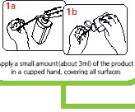Howtohandrub1
WITHALCOHOLHANDRUB

Howtollandwuh?
WITHSON' ANDWATER

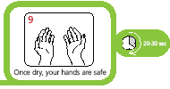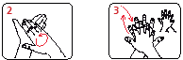
fh.bhandspa-ntop<L-n ll:ubkof8C'hhan1W!th
thel)<lknofu.herh:lnd...,;t.h
lingerti'ltf!:bO!d
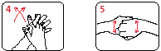
AutpaL-nto>.'tkny,ilh Rubwilhksdtingi!n
f;n;,>Mhle:bO!d 10oppOi!ngpa"r:-.swt.h
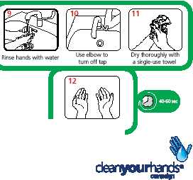fingeltintt!rold:ed
La\]

Rub8d'ltltur-.bda
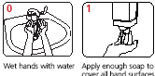
inopposi!ehtntfusing
llltiONIri'C\'elflf'lllt
Rub*soffillgf!lt
inqpw.ep.ll!rnin ac:inluiJr fl'IO.!iOn

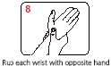
YourhandsareM:INsaie

SORT,SEGREGATE,SAVE

BLACK
DOMESTIC WASTE
BAG

Flowers, paper hand towels, packaging, newspapers, cans
ORANGE CLINICAL WASTE BAG

Contaminated dressings, wipes, gloves, masks, aprons

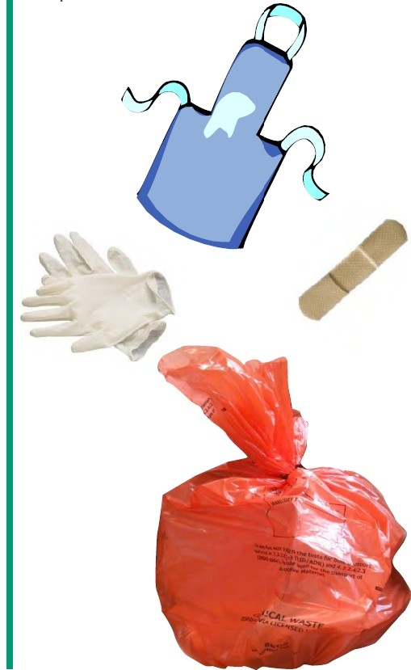"t' Tel:01501 822233 Fax:01501822211
7 E-mail:info@healthcareenv.co.uk www.healthcareenv.co.uk

WASTESEGREGATIONCOLOURCODEANDDEFINITIONS

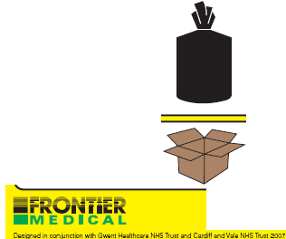
INFECTIOUS CLINICAL WASTE (For Disinfection)

HYGIENE WASTE
(For Landfill)

CYTO WASTE
(For Incineration)

CLEAN DRY WASTE FOR RECYCLING

GENERAL DOMESTIC WASTE (For Landfill)

CARDBOARD
(For Recycling)
CLINICAL WASTE PRODUCED BY INFECTIOUS PATIENTS and all items contaminated by blood or food products. All items contaminated by semen, vaginal secretions or fluids that are: cerebral, spinal, synovial, pleural, peritoneal, pericardial and amniotic (VASCAX).

NON INFECTIOUS WASTE
Continence pads and other produced from human hygiene (urine, faeces, sputum, tears, nasal secretions, vomit) equipment that does not pose a risk of infection (inhalers, gloves and plaster casts).

CYTO TOXIC & CYTOSTATIC CLINICAL WASTER PRODUCED BY INFECTIOUS PATIENTS and all items contaminated by blood or food products. All items contaminated by semen, vaginal secretions, fluids that are cerebral, spinal, synovial, pleural, peritoneal, pericardial and amniotic (VACSAX).

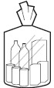
CLEAN DRY WASTE SUITABLE FOR RECYCLING
Office paper, Newspapers, Magazines, Packaging, Milk Cartons (Plastic), Clean Foils, Yoghurt Pots, Sandwich Wrappers, Unbroken Glass, Drinks Cans, Aerosol Cans, Hand Disinfectant Bottles, Empty Medicine Bottles, Toiletries: Shower Gel Bottles, Soap Packaging, Shampoo Bottles, Shaving Foam Cans etc. Please rinse containers before you place them in a recycling bag.

GENERAL DOMESTIC WASTE
General domestic waste not suitable for recycling.

Any Cardboard packaging such as computer or medical equipment boxes. Please flatten all cardboard boxes before placing them in the waste room.

FrontiEHP.t.edicalProducts.NgNbridgeRoadIndustrialEstate.Blackwood.
SouthWaelosNP122YN T+44(0)1495235800F+44(0)1495235eo8
Eenquireis@sharpsafe.co.ukwww.sharpsafiLCouk

Preventing and Managing

Sharps and Needlestick Injuries

How to prevent puncture injuries
•Always dispose of sharps immediately after use in a designated sharps bin
•Always take the sharps bin to the site of use and dispose of sharps directly into the sharps bin
•Always practice standard
precautions
•Never re-sheath needles or detach a needle from a syringe before disposal-You are risking a sharps injury
•Never allow sharps containers to fill above the designated line and do not press down to make more room
•Never pass used sharps between
colleagues – the user of the sharps is responsible for disposal
•Never clean up sharps
used by colleagues

FACTS

- Blood-borne viruses such as HIV, hepatitis Band hepatitis C can be contracted following a needlestick or sharps injury
- RCN survey of 4,407 nurses (Nov08) found that 48% had been stuck by a needle or sharp that had been previously used on a patient
- Over 36 sharps incidents were reported to the PCT last year there is considerable under reporting of sharps related injuries
What to do if an injury occurs

Encourage bleeding immediately

Wash puncture site thoroughly with soap and warm water. Cover with waterproof dressing

Ensure that your line manager is informed promptly of the incident. Complete an incident form and grade incident as 2 or more on the risk consequence table

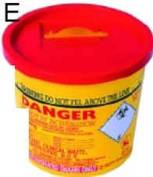
Contact Occupational Health immediately for further advice and risk assessment measures

Mattress Audit Tool

This Audit tool has been developed to monitor and record the condition of mattresses used in Community Intermediate Care facilities.

Mattresses should be individually numbered for identification purposes using an indelible pen. Each mattress and cover (if applicable) should be reviewed on a monthly basis and in accordance with manufacturer’s instructions.
When completed, this Mattress Audit Tool should be retained for evidence purposes.

This ‘Mattress Audit Tool’ has been adapted in response to the Care Quality Commission
Practice Alert September 2009: Mattresses.

Name of establishment
Mattress Location (bed space) |  | Mattress  Number
Form Completed by
Job title |  | Date

Criteria for mattress cover | Yes | No | N/A
- Is there a breach in the integrity of the mattress cover, e.g. torn or damaged? | ❑ | ❑
2. Is the mattress cover seal compromised, e.g. are the zip fasteners or any other cover fastening devices broken? | ❑ | ❑
3. Does the mattress cover have any soiling that cleaning cannot remove? | ❑ | ❑
If the answers to any of the above questions are yes, the mattress cover has failed and must be replaced. | Pass   | Fail   | ❑

Criteria for mattress | Yes | No | N/A
4. Is the mattress soiled or stained? | ❑ | ❑
5. Does the mattress have an offensive odour? | ❑ | ❑
6. Did the mattress cover fail the ‘Water Penetration Test’ (see overleaf) or is the mattress core wet/damp? | ❑ | ❑ | ❑
7. Did the mattress cover fail the ‘Hand Compression Assessment’ (see overleaf)? |  |  | ❑

If the answers to any of the above questions are yes, the mattress has failed and must be replaced. | Pass   | Fail  

Mattress and Mattress Cover Labelling | Yes | No | N/A
Is the mattress and mattress cover (if applicable) labelled with an identification number and dated when the mattress was put into use? | ❑ | ❑ | ❑
Is the mattress cover numbered to facilitate the mattress turning procedure? | ❑ | ❑ | ❑
Note: It may not be possible to label some mattresses and mattress covers (i.e. special mattresses). An appropriate system must be put in place to track these mattresses.

Water Penetration Test
1. Undo the zip and place a sheet of absorbent tissue(paper roll approximately 46cm x 46cm/ 18 x 18 Inches) between the top surface of the mattress and the cover.
2. Do up the zip/fastening.
3. Using the fist, indent the mattress over the area where the tissue is located to form a shallow well and pour tap water (about half a cup) into the well.
4. Agitate the surface with the fist for one minute and then mop up the water.
5. Undo zip and inspect tissue for water spots.
6. Repeat the procedure on the reverse side of the mattress.
7. The cover should be replaced if it is found to fail the above test or if it is damaged.
Hand Compression Assessment (Bottom-ing out test)
1. Adjust the height of the bed so that it is at the same level as the tester’s head of trochanter (hip)
2. Link hands to form a fist and place them on the mattress.
3. Keep elbows straight and lean forward, applying the full body weight to the mattress.
4. Repeat the hand compression along the entire length of the mattress.
5. Note any variation in the density of the form including whether the base of the bed can be felt through the foam.
6. The mattress should be condemned if it is found to ‘bottom out’. (Dunford C, 1994, Choosing a Mattress: Research findings Nursing Standard 8:20, 58-61)

If you have any queries, please contact the Infection Prevention and Control Team
Don’t judge a mattress by its cover
-·
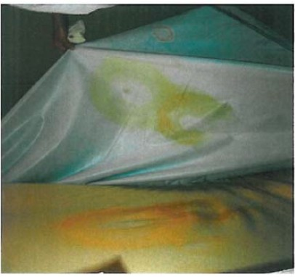
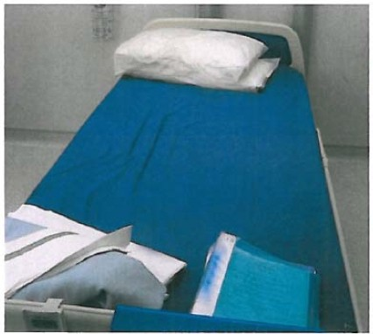
- Inspect the exterior surface of each mattress cover for signs of damage, such as hole or cuts.
- Remove the cover and inspect its surface and the mattress cover for contamination.
- Safely dispose of any covers showing signs of damage or staining.
- Arrange for contaminated mattress covers to be cleaned and decontaminated in accordance with the manufacturer’s instructions or safely disposed of.
- Ensure that the inspection routine is established for all mattresses.

What lies beneath?
The surface
Do the user instructions for the mattress properly describe how to inspect, clean and decontaminate it? If not, tell us about it by reporting it as an adverse incident.

Report adverse incidents online: www.mhra.gov.uk or on email: aic@mhra.gsi.gov.uk or telephone 02070843080

Commode Cleaning
Guide

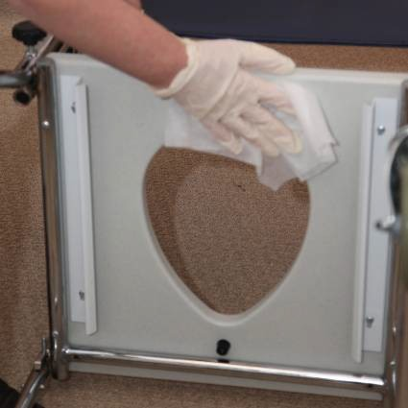
Wearing gloves and apron remove seat cover and clean all surfaces, with wipe.

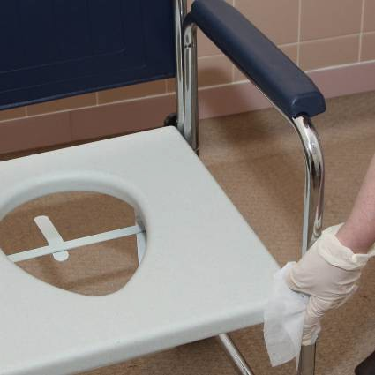

Using new wipe – Clean all remaining parts of frame.
Dispose of used wipes as clinical waste
Using new wipe – Remove seat (if possible) and clean all surfaces.

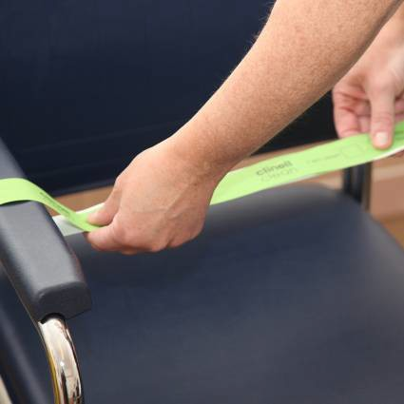

Remove PPE, Wash hands and fix indicator tape across arms of commode, sign and date tape.
Using new wipe – Clean seat back all surfaces.

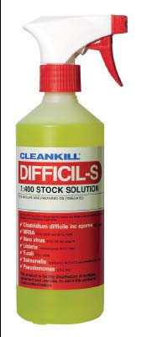
Difficile S solution for example, is a recognised and widely accepted solution to clean commodes

When cleaning commodes always ensure you wear gloves and an apron.
Ensure that commode is turned over to ensure all surfaces
(Top and bottom) are cleaned thoroughly

(Blank Page)

Reproduced with kind permission of NHS Leeds Community Health

